Astronomy Study Guide Name___________________________

1) Would we experience seasons if the Earth were not tilted on its axis? Explain your answer.

2) Label each of the following characteristics according to which word they most directly relate to, rotation, RT, or revolution, RV.
_____ a. Earth’s motion around the Sun _____ b. Sun rises in the east
_____ c. takes about one year _____ d. occurs in an elliptical shape
_____ e. partially responsible for seasons _____ f. responsible for day and night
_____ g. takes about one day _____ h. motion described by Kepler’s law
_____ j. Sun sets in the west _____ k. occurs around two foci

3) a. Draw a sketch of the positions of the Sun, Moon, and Earth for both a solar and lunar eclipse.

b. Which one can only occur during a full moon? The shadow of which celestial body causes the eclipse?

c. Which one can only occur during a new moon?

4) a. What type of tide is associated with a new or full moon? Is this tide higher or lower than normal?

b. What type of tide is associated with a quarter moon? Is this tide higher or lower than normal?

5) What has caused the Earth’s circumference to become wider at the equator?

6) What form of energy is created through the process of photosynthesis?

7) Indicate each of the following as being true or false.
_____ Our Milky Way galaxy contains all of the universe.
_____ The Sun is the only star in our solar system.
_____ A galaxy is made up of many planetary systems.
_____ Planets are typically larger in mass than stars.
_____ Our solar system is stationary within the galaxy.
_____ Our Sun moves around the barycenter of the solar system.
_____ Barycenter of solar system will always be near the Sun, but not at its center.

8) Why do we know that the universe is expanding?

9) Fusion is the process by which the Sun creates energy. Explain what happens during this process.

10) What process will cause us to experience the seasons at opposite times in 13 000 years?

11) a. At which position is the southern hemisphere going to experience winter? Summer?
b. At which positions are both hemispheres going to experience about equal distribution of light?
c. At which position is the Sun going to be at its highest altitude in the northern hemisphere? The lowest altitude?
d. At which position is the northern hemisphere experiencing the autumnal equinox? Vernal equinox?
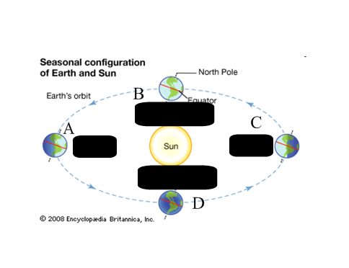
12) Match one of the following numbers with the appropriate description: ¼, ¾, or ½ portion
_____a. amount of light visible on side of moon facing the Earth during quarter moon
_____ b. amount of light reflected off of moon during any phase
_____ c. amount of light visible on side of moon facing the Earth during crescent moon
_____ d. amount of light visible on side of moon facing the Earth during gibbous moon

13) Match one of the following letters with the appropriate description below:
a. Xray, b. Gamma, c. UV, d. Visible light, e. infrared, f. protons, g. electrons
_________ I. These two are prevented from reaching Earth’s surface due to Earth’s atmosphere
_________ II. These two are responsible for creation of auroras and are intercepted by Earth’s magnetic field
_________ III. These 4 are very common forms of energy along the electromagnetic spectrum released from Sun

14) Mr. McLean is lifting weights. He has placed plates on two barbells. He accidently placed a 10 lb plate opposite a 5 lb plate on dumbbell A. Dumbbell B has a 10 lb plate on either side. In general, where would the center of mass be for Dumbbell A? Where would the center of mass be for Dumbbell B?

15) What do we call the phenomenon in which Earth’s tilt alters due to moon’s gravitational pull?

16) Write the numbers 1-4 for each of the following, indicating the order in which they occurred.
_____ continued to attract more matter _____ matter begins to combine _____ spin around center of mass
_____ begins to have an increased gravitational pull

17) During months of December through March, which hemisphere is experiencing least direct sunlight?

18) What major factor describes the difference between solar winds and solar flares?

19) Label each of the following as summer (S) or winter (W) solstice related.
_____ miniumum sunlight _____ highest altitude in sky
_____ maximum sunlight _____lowest altitude in sky

